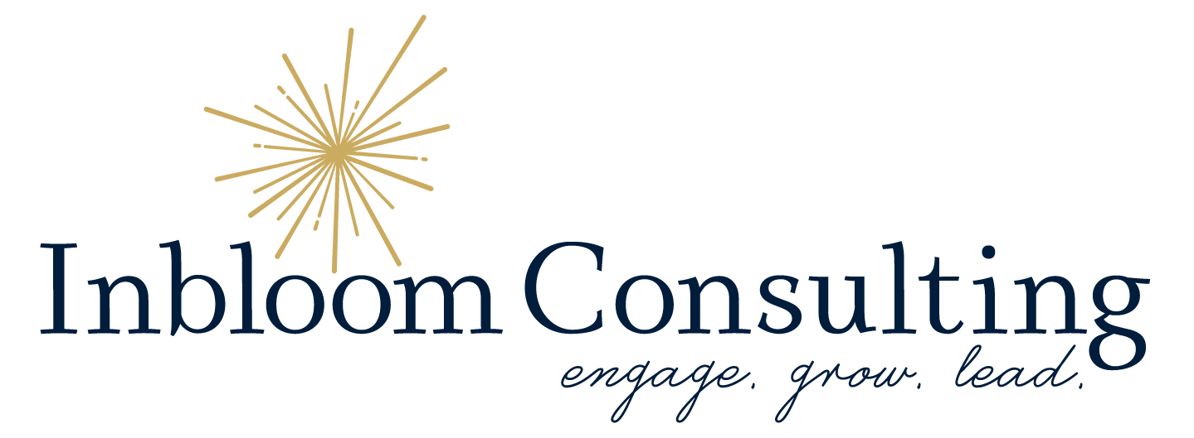
Checklist for Optimizing Social Media Profiles
☐ Ensure usernames and URLs are consistent across platforms to make it easy to remember on different social media platforms.
☐ Review each profile to ensure that branding elements such as logos, colors, fonts, and key messaging are consistent with the overall brand identity.
☐ Check image sizes and make sure they are optimal for each platform. It is good practice to change out cover photos monthly.
Resource - Social Media Image Size Cheat Sheet
☐ Ensure bios are clear and concise descriptions of your business, including keywords relevant to your industry. Relevant keywords in your social profile assist with SEO (Search Engine Optimization.)
Resource - Google Keyword Planner
☐ Use hashtags in captions to enhance visibility. Hashtags function like SEO on social media platforms, especially Twitter and Instagram.
☐ Write hashtags in camel case, capitalizing each word to make it easier to read and more accessible to individuals with vision impairments (#DinnerRecipes).
☐ Check call-to-action buttons like "Contact Us” to ensure they function correctly and lead to the appropriate pages.
☐ Review pinned posts and look for outdated information. If you are not currently utilizing pinned posts, you should consider doing so. Pinned posts can be a valuable tool for highlighting important content and keeping it visible at the top of your profile.
☐ If eligible, apply for a verification badge to add credibility to your profile. For most platforms, you will find this option under “Settings” and “Account.”
☐ Ensure your content is accessible to all users, including those with disabilities. This includes writing alt text, image descriptions, and captions.
☐ Use Geotags on platforms when available. Geotags on social media are tags that indicate the geographical location of photos, videos, or posts. On Facebook use the check-in feature, on Instagram use the location feature, enable precise location on tweets, and try location filters if you are using Snapchat.
Contact Inbloom Consulting for a Digital and Social Media Audit including profile optimization strategies.

